CSCI101 Final Project Submission

Assignment Description
- Download the input
- Process the Given Input Data
- Determine the Maximum x and y
- Create a 2D Array initialized with spaces
- Fill the array with characters from the Input Data
- Print the array to reveal the answer of block annotated letters

1. Readme Documentation
Per Professor Jenkin’s guidance, please refer to the GitHub repo linked below which has my README document at the root.

2. Flowchart Screen Shot
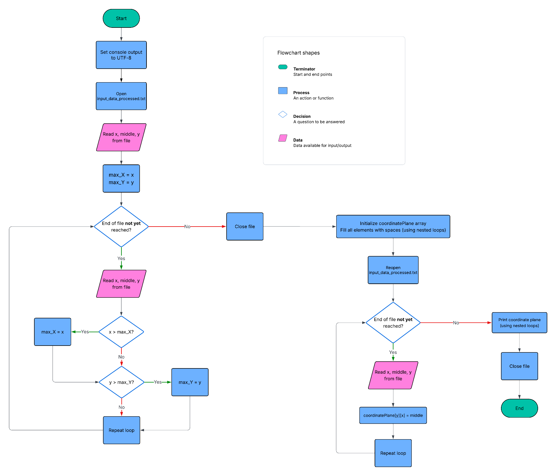
I generated my flowchart using Lucidchart, which is a flowcharting tool I’ve used at work before and am familiar with.

3. UML and Use Case Diagrams
Since neither the course shell nor this template give guidance on which UML diagrams are expected (other than a use case diagram), I made a use case diagram and then chose two other UML diagrams that made the most sense to me for this program (activity and sequence diagrams). I have attached all 3 below.

Activity Diagram

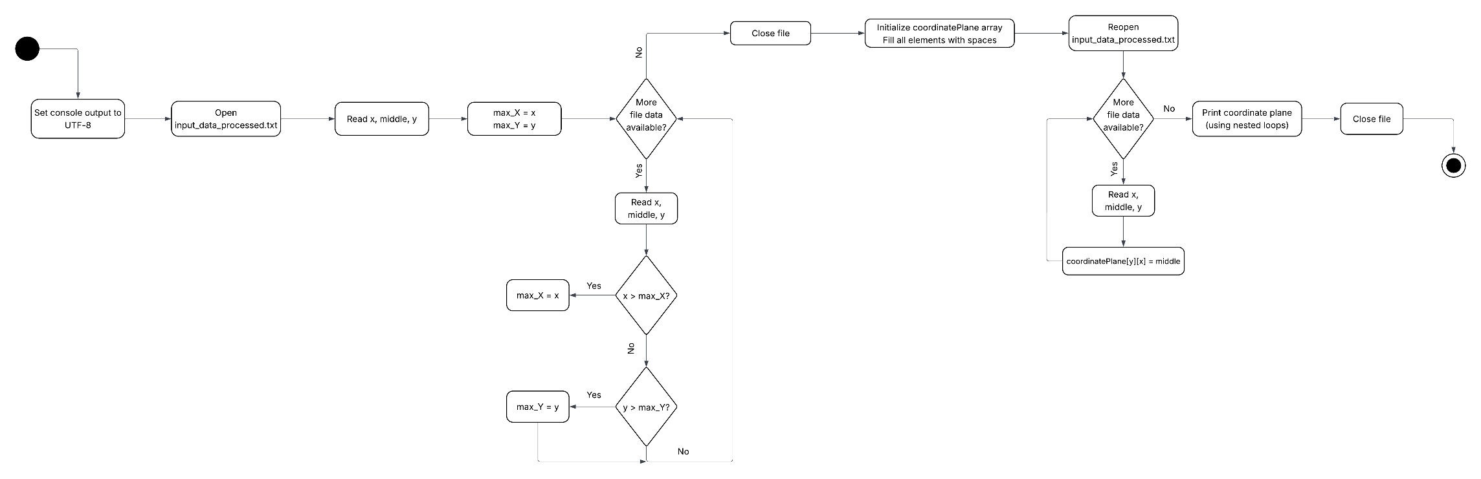

Sequence Diagram

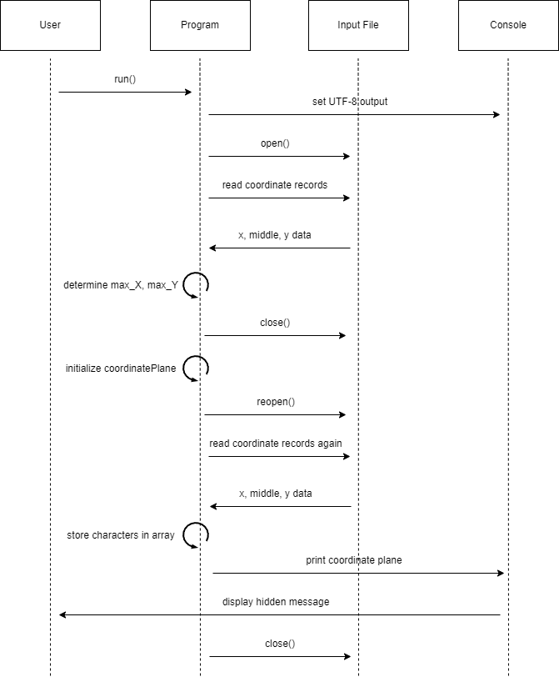

Use Case Diagram
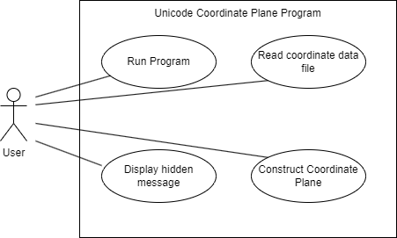

4. Source Code of All files (.h, .cpp)
Per Professor Jenkin’s guidance, please refer to the GitHub repo linked below which has my source code in the “Code” folder. The source code file is titled “main_program.cpp”.

5. Three Use Case Screen Shots
I’m not sure why this template instructs us to include 3 screenshots of the same answer, especially when the course shell only tells us to include one. My screenshot is below, if more are needed please let me know.
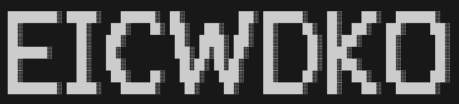

6. GitHub URL (Optional)
https://github.com/holdencoffman/CSCI-101-final-project

